Nathan Ketterlinus

ENGL317-002

Professor Charney

10/2/23

Assignment #2

TO: Jensen Huang

FROM: Nathan Ketterlinus Consulting LLC  
 DATE: 10/2/23  
 SUBJECT: Financial strength analysis of Nvidia

This report aims to analyze Nvidia’s (NVDA) market position in the semiconductor industry by comparing them to two of their self-described largest competitors, Intel Corporation (INTC), and Advanced Micro Devices, Inc. (AMD) (Nvidia Corp, 2023, p. 10). Put simply, by all metrics measured, Nvidia is in a dominant position coming out of the COVID-19 pandemic, and is poised to drive Intel and AMD’s semiconductors to obsolescence if current trends continue. This analysis will look at the following information:

1. Five key market metrics across NVDA, INTC, and AMD;
2. NVDA’s growth in the semiconductor industry, both recently and historically;
3. How this information can be applied.

## **Five Key Market Metrics**

Compared to AMD and Intel, Nvidia has much better financial metrics by quite a large margin. Referencing data found in table 1, they have:

* Over six times the market cap of either competitor;
* A 50% higher quick ratio;
* A significantly higher P/E ratio than the S&P Semiconductor ETF, which holds stock in all three companies and can be used as an industry benchmark;
* A return on assets (RoA) twice the industry benchmark, while both Intel and AMD are negative;
* A positive earnings per share (EPS), while, again, both Intel and AMD are negative.

Table 1

|  | **Market Cap** | **Quick Ratio**  **(TTM)** | **P/E Ratio** | **Return on Assets**  **(TTM)** | **Earnings per Share** |
| --- | --- | --- | --- | --- | --- |
| **Industry Benchmark** | N/A | 0.88  (csimarket, 2023) | 23.00  (XSD ETF)  (Yahoo!, 2023d) | 7.56%  (XSD ETF) (Yahoo!, 2023d) | N/A |
| **Nvidia** | $1.064 T  (Yahoo!, 2023c) | 2.37  (Macrotrends, 2023f) | 109.87  (Macrotrends, 2023e) | 14.51%  (Yahoo!, 2023c) | 4.14  (Yahoo!, 2023c) |
| **Intel** | $147.334 B  (Yahoo!, 2023b) | 1.15  (Macrotrends, 2023d) | 90.37  (Macrotrends, 2023c) | -0.84% (Yahoo!, 2023b) | -0.23  (Yahoo!, 2023b) |
| **AMD** | $166.026 B  (Yahoo!, 2023a) | 1.58  (Macrotrends, 2023b) | 55.14 (Macrotrends, 2023a) | -0.35% (Yahoo!, 2023a) | -0.04  (Yahoo!, 2023a) |

Comparison between Nvidia, Intel, AMD, and industry benchmarks across their Market Cap, Quick Ratio, P/E Ratio, RoA, and EPS, current as of Q3 2023 (various sources).

These metrics show Nvidia’s financial strength in a few key ways. The large market cap, combined with a high quick ratio, means that while Nvidia is one of the largest companies in their market, they simultaneously have the stability to stay afloat, even through unfavorable conditions. In addition, the high P/E ratio, RoA, and EPS highlights Nvidia’s profitability, which is an important factor in keeping and attracting new investors.

## **Recent and Historic Growth**

Nvidia has experienced astronomical growth over the last 3 years. This is in contrast to slow, steady growth since the company went public in January 1999. This is largely due to proper handling of supply chain issues both during and after the pandemic, as well as effective branding towards crypto miners and gamers, two of the most lucrative target audiences for graphics cards. This explosive growth is captured in image 1, which highlights Nvidia’s stock price growth since it went public, as compared to both AMD and INTC. Similarly, image 2 compares NVDA to the S&P 500 over the last year, where NVDA has significantly outperformed expectations.

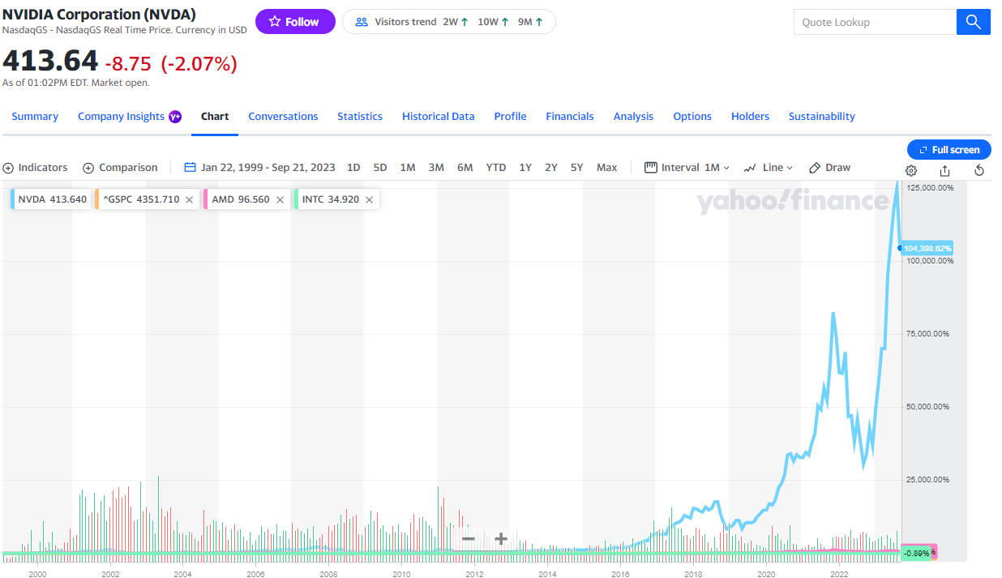

Image 1: comparison between Nvidia Corporation (NVDA, light blue), Advanced Micro Devices, Inc. (AMD, Pink), Intel Corporation (INTC, green), and S&P 500 (GSPC, orange), since 1/22/99, scaled by percentage (Yahoo, 2023a).

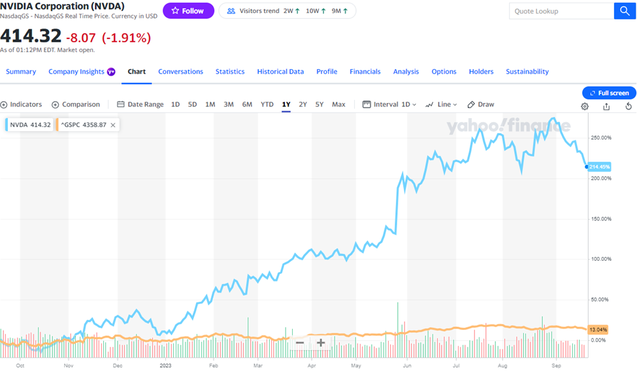

Image 2: comparison between Nvidia Corporation (NVDA, light blue) and S&P 500 (GSPC, orange), from 9/21/22 to 9/21/23, scaled by percentage (Yahoo, 2023c).

## **Applications of Data**

In short, not much needs to change for Nvidia to continue to be successful. They are the strongest competitor in the semiconductor industry by far. While AMD and Intel’s semiconductor segments are standing on shaky ground, Nvidia continues to take more and more market share, as highlighted in table 3. As long as Nvidia continues to effectively market products, create competitive graphics cards, and manage their supply chain (which they have proven they can do), there should be nothing stopping them from continued growth into the future.

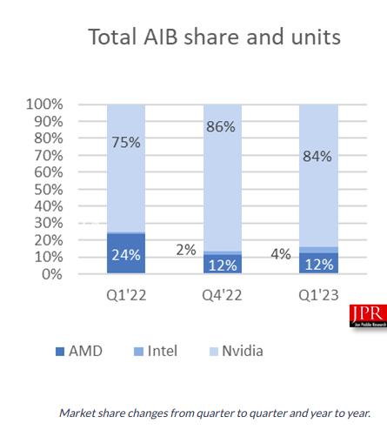

Image 3: market share between AMD, Intel, and Nvidia across the Add-in Board market (Dow, 2023).

## **To Summarize**

Nvidia is a thriving company which dwarfs its competition. Where AMD and Intel falter in market-specific metrics, Nvidia is leaps and bounds ahead. Coming out of the pandemic, the historically slow & steady company skyrocketed in value as they took over the semiconductor market. As long as they continue to do what they have been doing, they will continue to see economic growth into the future.

References

AMD PE Ratio 2010-2023: AMD. Macrotrends. (2023a). <https://www.macrotrends.net/stocks/charts/AMD/amd/pe-ratio>

AMD Quick Ratio 2010-2023: AMD. Macrotrends. (2023b). <https://www.macrotrends.net/stocks/charts/AMD/amd/quick-ratio>

Dow, R. (2023, June 7). *The graphics add-in board market continued its correction in Q1 2023*. Jon Peddie Research. <https://www.jonpeddie.com/news/the-graphics-add-in-board-market-continued-its-correction-in-q1-2023/>

Intel PE ratio 2010-2023: INTC. Macrotrends. (2023c). <https://www.macrotrends.net/stocks/charts/INTC/intel/pe-ratio>

Intel Quick Ratio 2010-2023: INTC. Macrotrends. (2023d). <https://www.macrotrends.net/stocks/charts/INTC/intel/quick-ratio>

Nvidia Corp (2023) *Form 10-K*. U.S. Securities and Exchange Commission.<https://www.sec.gov/ix?doc=/Archives/edgar/data/1045810/000104581023000017/nvda-20230129.htm>

Nvidia PE ratio 2010-2023: NVDA. Macrotrends. (2023e). <https://www.macrotrends.net/stocks/charts/NVDA/nvidia/pe-ratio>

Nvidia Quick Ratio 2010-2023: NVDA. Macrotrends. (2023f). <https://www.macrotrends.net/stocks/charts/NVDA/nvidia/quick-ratio>

Semiconductors Industry Financial Strength Information. Semiconductors Industry financial strength, from the Q2 2023 to 2 Q 2022, leverage, interest, debt coverage and quick ratios. (2023, September 13).

<https://csimarket.com/Industry/industry_Financial_Strength_Ratios.php?ind=1010>

Yahoo! (2023a, September 14). Advanced Micro Devices, Inc. (AMD) valuation measures & financial statistics. Yahoo! Finance. [https://finance.yahoo.com/quote/AMD/key-statistics?p=AMD](https://csimarket.com/Industry/industry_Financial_Strength_Ratios.php?ind=1010)

Yahoo! (2023b, September 14). Intel Corporation (INTC) valuation measures & financial statistics. Yahoo! Finance. <https://finance.yahoo.com/quote/INTC/key-statistics?p=INTC>

Yahoo! (2023c, September 14). Nvidia Corporation (NVDA) valuation measures & financial statistics. Yahoo! Finance. <https://finance.yahoo.com/quote/NVDA/key-statistics?p=NVDA>

Yahoo! (2023d, September 14). SPDR S&P semiconductor ETF (XSD) stock price, news, Quote & History. Yahoo! Finance. <https://finance.yahoo.com/quote/XSD?p=XSD>